OFFICIAL AMERICAN KENNEL CLUB FIELD TRIAL or HUNT TEST ENTRY FORM
Club:

Montana Brittany Club
Location:

Race Track Grounds, Acton, MT
Date: |  |  |  |  | Event Number: |  |  |  |  |  |  |  |  | Event Type Test or Trial:
April 13, 2019 |  |  |  |  | 2019682102 |  |  |  |  |  |  |  |  | Hunt Test
Enter in Stake/Test: |  |  |  |  |  |  |  |  |  |  |  | I enclose entry fees
 |  |  |  |  |  |  |  |  |  |  |  | in the amount of: $
Breed: |  |  |  |  |  |  | Reg. #: |  |  |  |  |  |  |  | Sex: | Date of Birth:
 |  | AKC No. |  | AKC Litter No. |  |  |  |  | ILP No. |  | Foreign No. & list country
Full Name of Dog: |  |  |  |  |  |  |  |  |  |  |  |  |  |  |  | Call Name:
Sire:
Dam:
Name of Breeder:
Name of Actual Owner(s):
Owners Address:
City: |  |  |  |  |  |  |  |  |  |  |  |  | State: |  |  | Zip:
Name of Owner's Agent/Handler:
AKC Rules, Regulations, Policies and Guidelines are available on the American Kennel Club website: www.akc.orq

AGREEMENT
I (we) agree that the dub holding this event has the right to refuse this entry for cause, which the club shall deem sufficient. In consideration of the acceptance of this entry and of the holding of this event and of the opportunity to have the dog judged and to win prizes, ribbons, or trophies, I (we) agree to hold the AKC, the event-giving club, their members, directors, governors, officers, agents, superintendents or event secretary and the owner and/or lessor of the premises and any provider of services that are necessary to hold this event and any employees or volunteers of the aforementioned parties, and any AKC approved judge, judging at this event, harmless from any claim for loss or injury which may be alleged to have been caused directly or indirectly to any person or thing by the act of this dog while in or about the event premises or grounds or near any entrance thereto, and I (we) personally assume all responsibility and liability for any such claim; and I (we) further agree to hold the aforementioned parties harmless from any claim for loss, injury or damage to this dog.

Additionally, I (we) hereby assume the sole responsibility for and agree to Indemnify, defend and save the aforementioned parties harmless from any and all loss and expense (including legal fees) by reason of the liability imposed by law upon any of the aforementioned parties for damage because of bodily injuries, including death at any time resulting there from, sustained by any person or persons, including myself (ourselves), or on account of damage to property, arising out of or in consequence of my (our) participation in this event, however such, injuries, death or property damage may be caused, and whether or not the same may have been caused or may be alleged to have been caused by the negligence of the aforementioned parties or any of their employees, agents, or any other persons. I (WE) AGREE THAT ANY CAUSE OF ACTION, CONTROVERSY OR CLAIM ARISING OUT OF OR RELATED TO THE ENTRY, EXHIBITION OR ATTENDANCE AT THE EVENT BETWEEN THE AKC AND MYSELF (OURSELVES) OR AS TO THE CONSTRUCTION, INTERPRETATION AND EFFECT OF THIS AGREEMENT SHALL BE SETTLED BY ARBITRATION PURSUANT TO THE APPLICABLE RULES OF THE AMERICAN ARBITRATION ASSOCIATION. HOWEVER, PRIOR TO ARBITRATION ALL APPLICABLE AKC BYLAWS, RULES, REGULATIONS AND PROCEDURES MUST FIRST BE FOLLOWED AS SET FORTH IN THE AKC CHARTER AND BYLAWS, RULES, REGULATIONS, PUBLISHED POLICIES AND GUIDELINES.
Signature of owner or his agent duly authorized to make this entry |  |  |  |  |  | __________________________________________
Address of Agent/Handler if different than Owner’s address:
City: |  |  |  |  |  |  |  |  |  |  |  |  | State: |  |  | Zip:
Telephone: |  |  |  |  | Email Address:
Please mail in your MEAL FORM (see last page) with your entries.
OFFICIAL AMERICAN KENNEL CLUB FIELD TRIAL or HUNT TEST ENTRY FORM
Club:

Montana Brittany Club
Location:

Race Track Grounds, Acton, MT
Date: |  |  |  |  |  |  | Event Number: |  |  |  |  |  |  |  | Event Type Test or Trial:
April 14, 2019 |  |  |  |  |  |  | 2019682103 |  |  |  |  |  |  |  | Hunt Test
Enter in Stake/Test: |  |  |  |  |  |  |  |  |  |  |  |  | I enclose entry fees
 |  |  |  |  |  |  |  |  |  |  |  |  | in the amount of: $
Breed: |  |  |  |  |  |  |  | Reg. #: |  |  |  |  |  |  |  | Sex: | Date of Birth:
 |  | AKC No. |  | AKC Litter No. |  |  |  |  |  | ILP No. |  | Foreign No. & list country
Full Name of Dog: |  |  |  |  |  |  |  |  |  |  |  |  |  |  |  |  | Call Name:
Sire:
Dam:
Name of Breeder:
Name of Actual Owner(s):
Owners Address:
City: |  |  |  |  |  |  |  |  |  |  |  |  |  | State: |  |  | Zip:
Name of Owner’s Agent/Handler:
AKC Rules, Regulations, Policies and Guidelines are available on the American Kennel Club website: www.akc.orq

AGREEMENT
I (we) agree that the dub holding this event has the right to refuse this entry for cause, which the club shall deem sufficient. In consideration of the acceptance of this entry and of the holding of this event and of the opportunity to have the dog judged and to win prizes, ribbons, or trophies, I (we) agree to hold the AKC, the event-giving club, their members, directors, governors, officers, agents, superintendents or event secretary and the owner and/or lessor of the premises and any provider of services that are necessary to hold this event and any employees or volunteers of the aforementioned parties, and any AKC approved judge, judging at this event, harmless from any claim for loss or injury which may be alleged to have been caused directly or indirectly to any person or thing by the act of this dog while in or about the event premises or grounds or near any entrance thereto, and I (we) personally assume all responsibility and liability for any such claim; and I (we) further agree to hold the aforementioned parties harmless from any claim for loss, injury or damage to this dog.

Additionally, I (we) hereby assume the sole responsibility for and agree to Indemnify, defend and save the aforementioned parties harmless from any and all loss and expense (including legal fees) by reason of the liability imposed by law upon any of the aforementioned parties for damage because of bodily injuries, including death at any time resulting there from, sustained by any person or persons, including myself (ourselves), or on account of damage to property, arising out of or in consequence of my (our) participation in this event, however such, injuries, death or property damage may be caused, and whether or not the same may have been caused or may be alleged to have been caused by the negligence of the aforementioned parties or any of their employees, agents, or any other persons. I (WE) AGREE THAT ANY CAUSE OF ACTION, CONTROVERSY OR CLAIM ARISING OUT OF OR RELATED TO THE ENTRY, EXHIBITION OR ATTENDANCE AT THE EVENT BETWEEN THE AKC AND MYSELF (OURSELVES) OR AS TO THE CONSTRUCTION, INTERPRETATION AND EFFECT OF THIS AGREEMENT SHALL BE SETTLED BY ARBITRATION PURSUANT TO THE APPLICABLE RULES OF THE AMERICAN ARBITRATION ASSOCIATION. HOWEVER, PRIOR TO ARBITRATION ALL APPLICABLE AKC BYLAWS, RULES, REGULATIONS AND PROCEDURES MUST FIRST BE FOLLOWED AS SET FORTH IN THE AKC CHARTER AND BYLAWS, RULES, REGULATIONS, PUBLISHED POLICIES AND GUIDELINES.
Signature of owner or his agent duly authorized to make this entry |  |  |  |  |  | __________________________________________
Address of Agent/Handler if different than Owner’s address:
City: |  |  |  |  |  |  |  |  |  |  |  |  |  | State: |  |  | Zip:
Telephone: |  |  |  |  | Email Address:

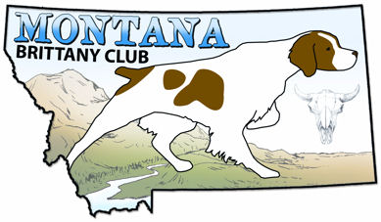

AKC Event #’s: 2019682102 & 2019682103
HUNT TEST PREMIUM LIST
Double/Double with the North Dakota Pointing Dog Club
For entry forms see: www.ndpdc.org/springhunttest

Montana Brittany Club
April 13 & 14, 2019

Racetrack Grounds
Acton, MT

LICENSED by the AMERICAN KENNEL CLUB (AKC)
Entries are limited to the number of dogs that can be run during daylight hours.
Entries will close when this limit is reached, if this occurs prior to the specified closing time.

This Hunt Test will be held under the rules and procedures of the
AMERICAN KENNEL CLUB

OPEN TO ALL AKC REGISTERED POINTING BREEDS
Bitches in season will be allowed to compete in the Junior Hunter Test only.

ENTRIES WILL NOT BE DRAWN WITHOUT A CHECK AND
COMPLETED, SIGNED ENTRY FORM(S). YOU ARE NOT ENTERED INTO THE
TEST(S) UNTIL THESE ARE RECEIVED. CHECKS WILL NOT BE CASHED UNTIL THE EVENT CLOSES.

Mail completed entries and checks (Payable to MTBC) to:
Jan Breitenfeldt, Hunt Test Secretary
P.O. Box 883
Whitehall, MT 59759

Phone: (406)498-3459 Email: jzbreit@gmail.com
Entries will close with the Hunt Test Secretary at the above address on
Tuesday, April 9, 2019 at 6:00 P.M. MDT

Drawing will take place at ,
107 1st West, Whitehall, MT 59759 on Wednesday April 10, 2019 at 6:00 PM MDT
Running Order will be posted at http://montanabc.org/
Montana Brittany Club reserves the right to change the running order depending on numbers of entries received and the weather.
HUNT TEST COMMITTEE
Chair: Todd Breitenfeldt, Jan Breitenfeldt, Alex Burks, Tommie Dahl, Cheyenne Raisor-Grinnell

Saturday, April 13, 2019
AKC Event #: 2019682102
Test Schedule, Fees, and Judges
Entry Fees Includes: $3.50 AKC fee,

Judges (All Tests)
R J Marquart (Z7864) 8998 Road 18 NE Moses Lake, WA 98837
Ken Barber (23928) PO Box 1487, Seeley Lake, MT 59868

Master Hunter | Saturday April 13, 2019 8:00 A.M. | $55.00
Senior Hunter | To follow Master Hunter | $55.00
Junior Hunter | To Follow Senior Hunter | $55.00

Sunday April 14th, 2019
AKC Event #: 2019682103
Test Schedule, Fees, and Judges
Entry Fees Includes: $3.50 AKC fee

Judges (All Tests)
Ken Barber (23928) PO Box 1487, Seeley Lake, MT 59868R
Tim Bintner (23826) 6917 Sapphire Pointe Blvd. Castle Rock, CO 80108

Junior Hunter | Sunday April 14, 2019 8:00 A.M. | $55.00
Senior Hunter | To follow Junior Hunter | $55.00
Master Hunter | To Follow Senior Hunter | $55.00

COURSES AND BIRDS
All Tests will be run on a single course, with a birdfield. Quail will be released in all Tests.

PRIZES
Standard Rosettes to all dogs with a qualifying score

AKC Approved tracking devices will be allowed.

SCRATCH POLICY AFTER CLOSING DATE
Entries will be refunded in full only for dogs that have an injury or illness that prevents running in the registered stake or that are deceased prior to running in the registered stake. Club may require an appropriate veterinary certificate.

AKC Hunting Test

For Your Safety…
All Handlers and spectators must wear an article of orange. NO EXCEPTIONS!! Spectators will need to be with a field marshal to observe the brace. If you do not have an article of orange, please see a club member to obtain one for use at the event. When done using, please return that article to the club.

These events do require the use of dogs and horses. The Hunt Test Committee can not guarantee the disposition of these animals. We ask that parents do not allow their children to approach the dogs and horses while they are tied out (without permission). We don’t want to see anyone get bit, kicked, wrapped up in chains or hurt in any way.

Junior Hunting Test: A Junior hunting dog must show a keen desire to hunt, be bold and independent, have a fast, yet attractive, manner of hunting, and demonstrate not only intelligence in seeking objectives, but also the ability to find game. A Junior hunting dog must establish point on at least fifty (50) percent of the birds it encounters, but no additional credit shall be given for steadiness to wing and shot. If the handler is within reasonable gun range of a bird which has been flushed after a point, a blank cartridge must be fired by the handler. Junior hunting dogs must hold point until the handler gets within normal gunshot range. This requirement should be tempered by practical considerations such as the dog’s distance from the handler when it finds a bird. Junior hunting dogs must also show reasonable obedience to their handler’s commands.

Senior Hunting Test: A Senior hunting dog must show all of the attributes of a Junior hunting dog. In addition, the Senior hunting dog must be steady to wing on all pointed birds and must remain in position until the shot or they are released. A Senior hunting dog must retrieve. All birds that are pointed by the Senior dog in a bird field must be shot where safety allows. If gunning is being done on course, all birds pointed on course must be shot where safety allows. A legitimate attempt to retrieve all downed birds must be made. Conditions such as the type of cover where the bird landed, the terrain, and the condition of the downed bird, sometimes make a retrieve impossible, and this should not reflect negatively on the score of the Senior dog. Whenever it encounters its bracemate on point, it must honor. A dog that steals its bracemate’s point cannot receive a Qualifying score.

Master Hunting Test: A Master hunting dog must give a finished performance and demonstrate clearly that it deserves to be qualified as such. This is the complete hunting companion that any hunter would be proud to own. It must be under its handler’s control at all times, and handle kindly, with an absolute minimum of noise and hacking by the handler. A Master hunting dog must show a keen desire to hunt, must have a bold and attractive manner of running, and must demonstrate not only intelligence in seeking objectives, but also the ability to find game. The dog must hunt for its handler at all times at a range suitable for a handler on foot, and should show or check in front of its handler frequently. It must cover adequate ground but never range out-of-sight for a length of time that would detract from its usefulness as a practical hunting companion. The dog must locate game, must point staunchly, and must be steady to wing and shot on all birds and if it breaks, it cannot receive a Qualifying score. Intelligent use of the wind and terrain in locating game, accurate nose, and intensity on point are essential. Whenever it encounters its bracemate on point, it must honor. A dog that steals its bracemate’s point cannot receive a Qualifying score. A Master hunting dog must positively demonstrate its steadiness to wing and shot. All birds that are pointed by the Master dog in a bird field must be shot where safety allows. If gunning is being done on course, all birds pointed on course must be shot where safety allows. Gunning must be done by Official Guns only. A legitimate attempt to retrieve all downed birds must be made. Conditions such as the type of cover, where the birds landed, the terrain, and the condition of the downed bird, sometimes make a retrieve impossible and this should not reflect negatively on the score of the Master dog. All killed birds must be retrieved promptly, tenderly and absolutely to hand. The handler shall not command or signal the dog to retrieve until positive steadiness has been demonstrated.

Complete Hunt Test rules: http://images.akc.org/pdf/rulebooks/RHTPNT.pdf

Welcome to our 2019 April Hunt Test
A Double/Double with the North Dakota Pointing Dog Club

April 13 & 14, 2019
Race Track Grounds, Acton, MT

No electrical or water hook-ups are available. Bathroom facilities will be in the form of a porta-potty. Please bring adequate water for you and your animals.

AREA LODGING

Primitive camping is allowed on the grounds.

In Acton: Cowdin’s Carriage House B&B 406-652-5108

There are MANY hotels in Billings, MT.

FOOD & BEVERAGE
Breakfast of coffee and rolls will be provided complimentary each morning. Lunches will be served on the grounds daily for a nominal fee. Water will be available throughout the days. We will be going out to the 3 North Bar & Grill, 8369 Highway 3 N, Acton, MT (406-208-0770) on Saturday night for a Judges dinner and the presenting of ribbons.

EMERGENCY NUMBERS

Police, Fire, Ambulance: Emergency 911

Hospitals: Billings Clinic
2800 10th Ave N, Billings, MT
St. Vincent Hospital
1233 N 30th St., Billings, MT

Veterinary: Best Friends Animal Hospital. 406-225-0500.
1530 Popelka Drive, Billings, MT

Directions:
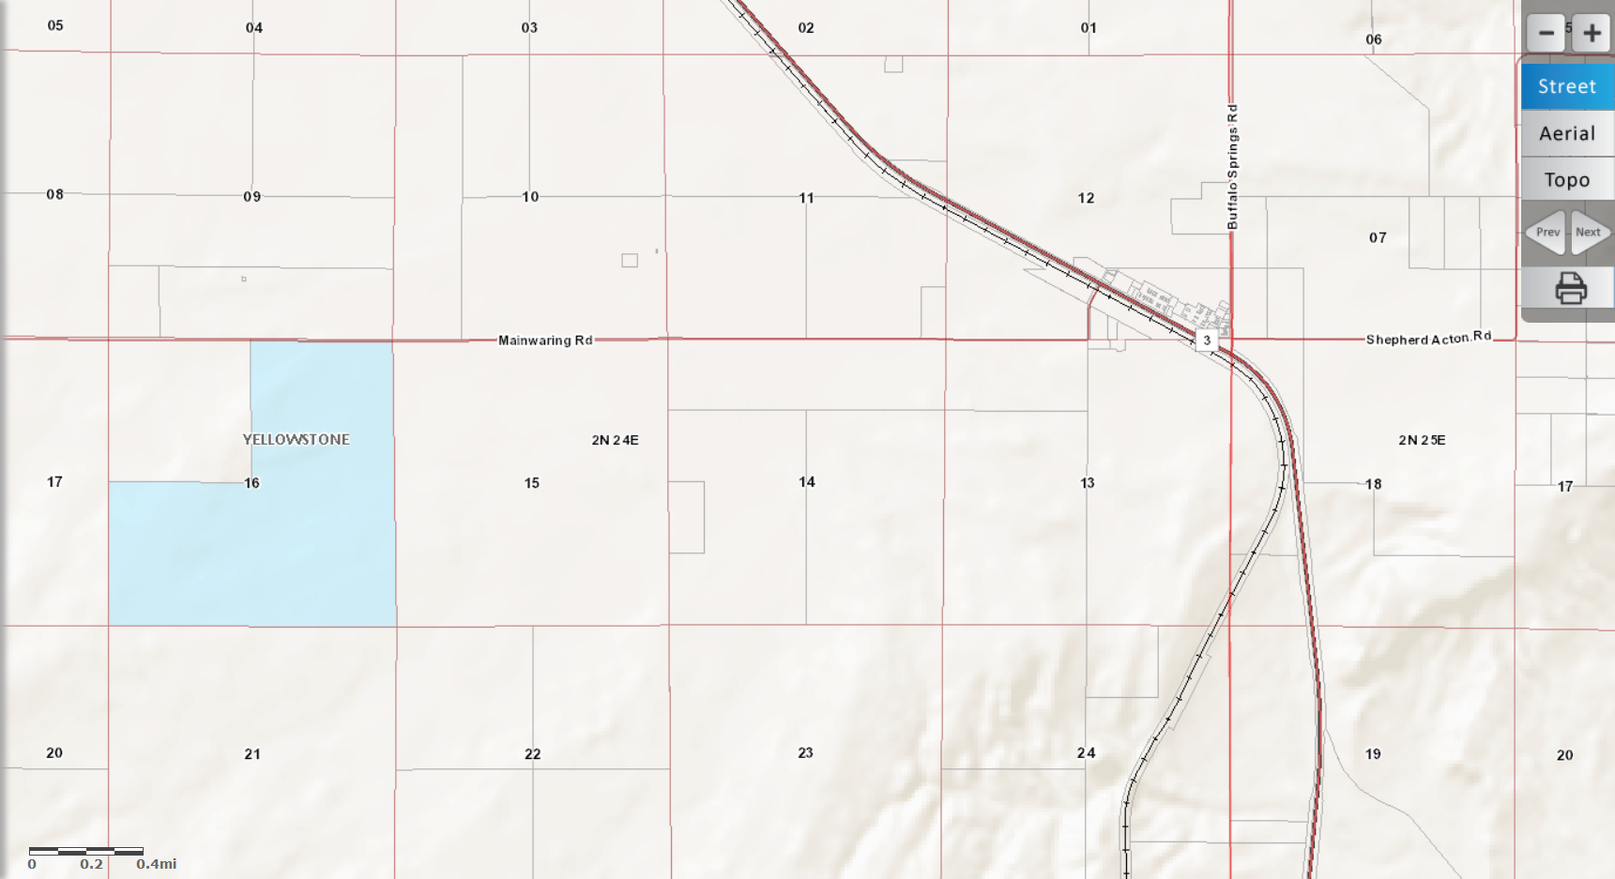

From I-90 in Billings take the 27th St. exit. Turn north onto 27th St. and follow it to the top of the hill heading towards the Billings airport. At the top of the hill you will hit a round-about. Go left through the round-about onto Highway 3 towards (Broadview) and Acton. Acton is about 14 miles northwest of Billings. At the small town of Acton, turn left onto Mainwaring Rd. Go about 3 miles west and follow the signs to the hunt test grounds on the left. The Hunt Test grounds are on the blue (State Land). Section 16, R2N, T24E.
Saturday Evening Meal Choices:
Entrée Choices
8 oz. Baseball Sirloin Steak…$19.95
Jumbo Grilled Shrimp…$24.95
Twisted Grilled Chicken…$14.95 topped with Provolone & Spinach/Artichoke Dip
Cajun Chicken Penne…$14.95 (Soup, Salad or 1 side)
Soup or Salad
Garden Salad – with choice of dressing- Ranch, Blue Cheese, 1000 Island, Italian, Russian, Low Fat Citrus Berry, Fat-free Raspberry
Soup of the Day.
Choice of One Side
Mashed Potatoes,
French Fries,
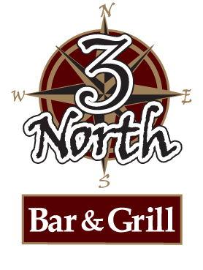
Baked Potatoes or
Veggie of the Day 3 North Bar & Grill, 8369 Highway 3 N, Acton, MT

MEAL FORM
If you are attending both the Montana and North Dakota events, you only need to send this Meal Form in once.

Print Name_______________________________

_____ Yes, I/we will be eating lunch on Saturday $5.00. How many in your party? _______

_____ Yes, I/we will be eating lunch on Sunday $5.00. How many in your party? _______
For the lunches, please pay at the event. Ribbons for the day will be awarded at Sunday lunch.

_____ Yes, I/we will be eating dinner at the 3 North Bar & Grill on Sat. How many in your party? ______
You will order Sat. evening and pay on your own. Ribbons for Saturday will be awarded at this dinner.

Please return this MEAL FORM with your entry forms. Thanks!
……………………………………………………………………………………………………………………………………………………………..

